

Green University of Bangladesh

Dept. of Computer Science & Engineering (CSE)

Faculty of Sciences and Engineering

Semester: (Fall, Year:2021), B.Sc. in CSE (Day)

Lab Project Report

**Course Title**: Structure Programming Lab **Course Code**: CSE-104

**Lab Project Name** : Number Guessing Game

**Submission Date** : Jan-08-2022

Course Teacher Details:

Name : Md. Humayan Kabir Rana

Lecturer, Department of CSE

Green University of Bangladesh

Student Details:

Name : Tarikul Islam

ID : 212002008

Batch : 212

Section : DB

Department of CSE

Green University of Bangladesh

**[For Teachers use only: Don’t Write Anything inside this box]**

|  |
| --- |
| **Lab Project Status**  **Marks: ……………………………………….. Signature: .....................**  **Comments: .................................... Date: ..............................** |

**Number Guessing Game**

**Chapter 1**

**Introduction**

**Introduction:**

The number guessing game is a game in which we estimate computer-generated numbers based on a hypothesis, and if our prediction is true, we are rewarded and learn how accurate our guess was. We can improve our guessing skills by playing this game, and eventually, we will be able to predict anything quite correctly.

**Design Goals/Objective:**

1. This is a fun game.
2. This game improves our IQ level.
3. This game is improving our thinking level.

**Chapter 2**

**Design/Development/Implementation of the Project**

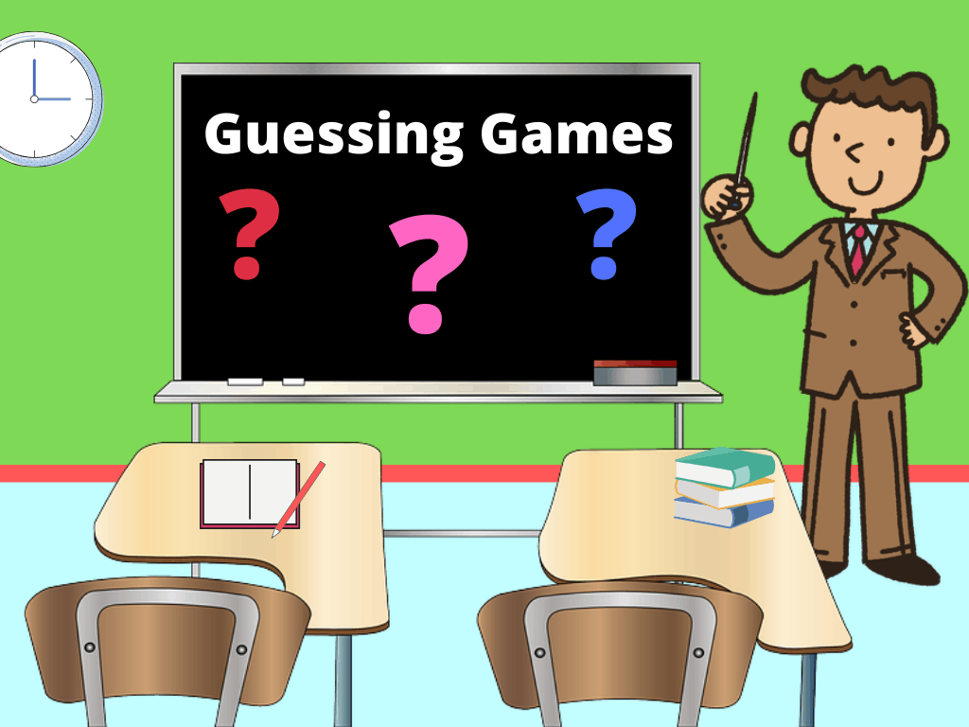**Game Design:** Number Guessing Game

Fig-1: Guess the Number

**Game Development:**

Generate Secret

Number

Ask to play or not play

End Main

SORRY!!

You try maximum times

CONGRATULATIONS

You are the winner

Ask third guessing

Number

Ask Second guessing

Number

Start Main

Ask first guessing

Number

**Implementation of the project:**

#include <stdio.h>

#include <stdlib.h>

#include <time.h>

int main() {

int i, number, currentGuess, MAX_GUESS = 3;

char play;

char answer;

time_t t;

srand((unsigned) time(&t));

number = rand() % 100 + 1;

printf("Did you play game of Guess!");

printf("\nIgnore this game press any key.\nPlay this gme press y or Y!\n");

scanf("%c", &play);

if(play == 'y' || play == 'Y'){

printf("Welcome to the game of Guess It!");

for (i = 0; i < MAX_GUESS; i++) {

printf("\nGuess Your Number: ");

scanf("%i", &currentGuess);

if (currentGuess > 100) {

printf("Illegal guess. Your guess must be between 1 and 200.\n");

printf("Try again.\n ");

}

else if (currentGuess > number) {

printf("Guess Low Number\n");

}

else if (currentGuess < number) {

printf("Guess High Number\n");

}

else {

printf("****CONGRATULATIONS****\nYou Are The Winner\nYou Are The Guessing Boss!");

return 0;

}

}

printf("****Sorry****\n\nYou tries maximum times.\nCorrect Guess Number: %d\nYou Are a Losser :-)", number);

}

else{

printf("Wish you try to next time?");

}

return 0;

}

**Chapter 3**

**Performance Evaluation**

**Simulation Environment/ Simulation Procedure:**

TOOLS & TECHNOLOGIES -

1. Programming Language: C
2. Visual Studio Code- GCC
3. Operating system Windows 11.

**Results:**

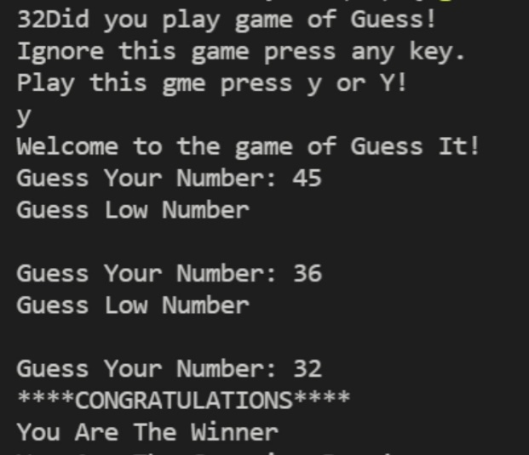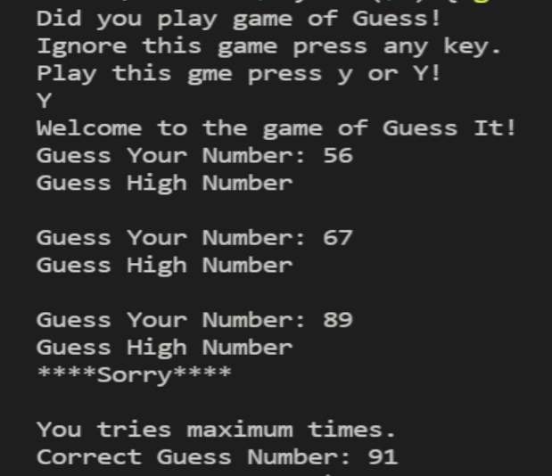

**Fig-1 Fig-2**

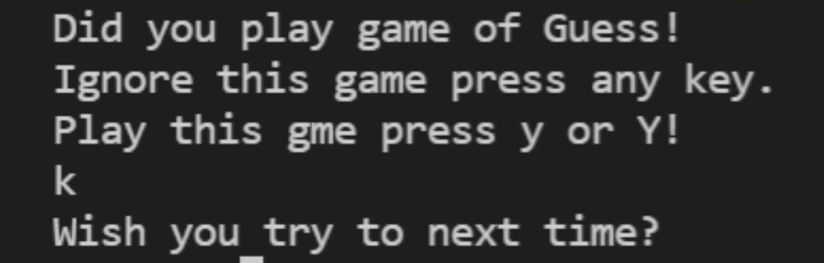

**Fig-3**

**Discussions:**

This application is easy to use and its interface is very simple that means application is user friendly.

**Chapter 4**

**Conclusion**

**Conclusion:**

As I am a beginner in using C programming language. So, I think it a good start with the project of number guessing game. Usually, the program of guessing game contains basic of c with a conditional statement, for loop and with some special functions.

**Practical Implications:**

The program can be used to build simple application software. Number guessing game has no limitation of specific subject. Its auto generated number and ask this number for user. If the user answers correctly, then congress the users and not guess the number then show sorry and play next time.

**Scope of Future Work:**

Finally, this project we will learn how to create a simple number guessing game in C program using vs code and this will increase our program skill level and help us to solve real life problems.

**END**